Your Name Here

Your Address Here

10th November 2020

Dear Mr Shapps,

I write to you in hope that you will personally look at the industry as a matter of priority and look at the reasons why driver training should be considered as more essential than what it is now, this is evident from the limited scope and attention that is being displayed, the guidance does not directly refer to the driver training industry, whereas others are very explicit such as leisure, barbers etc.

To my knowledge this email is being sent to many local MPs across the country and obviously yourself too as the Secretary of State for Transport who has responsibility for:

* Overall responsibility for the policies of the Department for Transport
* cabinet responsibility for the Northern Powerhouse
* oversight of departmental COVID-19 responsibilities

If the driver training doesn’t receive a satisfactory response in the near future from the Government, then this email will be circulated to the media to see if they can bring the concerns to your attention. You have responsibility for COVID-19 within the department, however it appears there has been lack of guidance and steer on this.

**Short-term issues:**

For the following reasons, there has been confusion within the driver training industry whether driving instructors are able to work during the current lockdown measures that have been put in place on 05th November:

* Driving lessons fall under the education category.
* DVSA have said driving lessons and tests have been suspended.
* Any suspension to my knowledge should be passed through the court of law.
* Legislation passed in Parliament recently does not state that driving lessons should not be conducted and puts an emphasis on how education and training should continue.
* Legislation passed on Wednesday 4th November 2020 repeats several times that you can work if “**it is reasonably necessary for the purposes of education or training”**.
* DSVA have issued correspondence by email over the last few days, including yesterday (Monday 9th November 2020), stating “you should not give lessons to any pupils from England or take them to a test in Wales”.
* The word ***‘should’*** *and* ***‘suspend’*** have two different meanings in my humble opinion. On the DVSA Twitter account they just say tests are suspended and don’t refer to driving lessons or driver training. The lack of consistency over different communicating platforms isn’t good enough.

**Problems the Driver Training industry currently facing are:**

* We can estimate around 5,000 to 8,000 instructors have left the industry or they haven’t come back to work since 4th July 2020. It’s hard to accurately assess the data as the DSVA have only released statistics up to June 2020. What we can see is there have only been 1265 ADI badge renewals in 2020/21 compared to 2019/20 figures showing 7185. Please bear in mind the ADI register has floated between 38,000 to 40,000 instructors over the past 5 years.
* Most of the damage was done to the industry between May 2020 to July 2020 when the DVSA remained silent throughout the lockdown when we needed answers, to which they failed to provide or ignored the pleas when asked during communication with them. This left the industry second guessing when they could work, especially with many instructors falling in the 3 million exempt from benefits. It was only by you forcing the DVSA’s hand by announcing we could work on 4th July 2020 as it started to be alerted in the public eye.
* I can promise you the 2020/2021 figures will be alarming. However, by the time they are published in 2021, the damage to thousands of instructors and learners would already have been done.
* The confusion within the industry compared to hair salons and gyms for example, makes the speculation and debate far worse as there is definitive answer in the legislation. The DVSA also do not help by being ambiguous and inconsistent with their wording and messaging, which is also not in a timely manner. This inconsistency causes the human brain (which for many instructors who are financially in a dire state and in a ‘survival mode’) to think and weigh up the risks of teaching or not teaching learners during this second lockdown as they simply cannot afford to stay at home.

**The consequences of not allowing instructors to work under essential work guidelines:**

* The waiting times for a driving test is realistically 9 months. When the DVSA release a new batch of tests, they will be booked up in days. We are currently waiting for May 2021 tests to be released at the time of writing. As mentioned, the moment they are released, any May slots will be taken within 1 week. All driving tests across the UK are booked.
* The Government’s goal is to stop the spread of the virus. There are 3 ways to generally travel to work safely to stop the spread - walk, cycle or drive.
* Roughly 1.5 million driving tests are conducted each year. With the lockdowns and lack of driving tests being conducted this year, this figure is going to be down by at least 60-70% by the end of the year. Have a look for yourself; driving examiners have been off work for approximately 5 months after the most recent lockdown. From 24th July 2020, they started tests very slowly and many test centres were not open until late August 2020.
* I believe the examiners were only back to normal testing hours for 7-8 weeks before the second lockdown was announced, they were not working at full capacity of 7 driving tests a day, but yet have been on full pay throughout the period, despite a drop in the income from driving test fees etc.
* People are losing their jobs at a colossal rate across the country. One of the biggest attractions to an employer is knowing the potential employee can drive. On top of that, the opportunity for someone searching for re-employment is much higher if they possess a driving licence. We can expect close to 750,000 to 1 million people who will not hold a driving licence as a result of the COVID-19 lockdowns and each time the Government prevents the industry from working this number will increase.
* We know the unemployment rate is going to significantly increase before it falls. While many people can still afford it (before furlough ends), does it not make sense to keep the driving tests going for the future of employment and prevent any more instructors throwing in the towel as they can’t afford to keep being locked down?
* If instructors keep leaving the industry, supply and demand will change. We have already seen it - the average lesson price across the UK has gone up by £3-5 an hour (my estimate, but feel free to check for yourself). This will continue to rise as we see more instructors leave the industry in the short-term. Only those who do not live week by week will hang in there for the long-term gains. However, for the public it will cost more and take longer to pass the driving test.
* Lesson prices will remain high until we see new instructors join the industry. The ADI register will not return to 38,000-40,000 for around 18-24 months, which is too late for those looking for jobs when furlough ends in March.

**Effect on DVSA**

The DVSA would have lost millions of pounds in testing due to the limited services being offered. As you will be aware the DVSA’s business plan for 2019/2020 was for 80% of testing to be conducted at a 6-week waiting time, with the customer measure that is being used.

The DVSA won’t get to that waiting time for at least 2 years, possibly even longer if the industry keeps getting put into lockdown, as well the natural wastage they will have with staff leaving and not being able to react and recruit in such a short term, as the training process takes many months.

It will take years to get the ADI register back to 40,000 that we were at before the Pandemic. For every 10,000 ADI badge renewals lost at £300, that’s a £3million loss in income.

DVSA are still paying staff a full-time wage despite not working at all or even at full capacity of 7 tests a day, they have an equivalent of 2,000 driving examiners who on average are on £26,000 approximately. They have not tested for 4 months though they have still been paid approximately £17,333,333.30. With no income from test fees during this time, how is that sustainable or can continue? Surely DVSA need to review this and their finances, as the self-employed and other organisations which are using the furlough scheme are only able to claim 80%. Is DVSA applying the furlough scheme? From this I can see why there is no rush for DVSA or its staff to be testing back anytime soon as they will be on full pay.

**Summary:**

At some point, we are going to be encouraged to return to work. However, there is going to be a lack of jobs and opportunities. Anyone without a driving licence is going to be at a significant disadvantage. For the next 6 months at least, driving lesson prices will be the highest they have been for 10 years. By July/August 2021, competition will start to come back as new instructors may want to enter the industry, but prices won’t stabilise to an affordable level for at least 12 months.

By allowing driving lessons to continue as essential line of work, you will do the following:

* Reduce the spread of the virus by enabling people to drive instead of relying on public transport.
* Prevent more instructors leaving the industry imminently, preventing the ADI register from falling below 30,000.
* Reduce the odds of small, medium and large driving schools who have spent years building up their business from calling it a day. We can’t afford to continue like this much longer.

**Recommendation:**

I would strongly recommend the use of face coverings to be made a compulsory measure like in Scotland so we can reduce the risk further and save lives.

**Consideration 1:**

Driving lessons are conducted with instructor and learner driver sitting side-by-side with minimal contact.

It’s not the same as hairdressers, who can be in your personal space and near your face for 1-2 hours. We know being side-by-side is better than being face-on to another person.

Physical intervention rarely happens in a driving lesson. The DVSA frown upon an instructor going into a pupil’s personal space unless it’s an emergency.

The best type of prevention is verbal, then after that it’s usually by physical in the form of applying the dual controls, you can request the data from DVSA who capture if physical intervention has taken place as well as verbal to have meaningful data.

**Consideration 2:**

I am unaware of any serious cases concerning the spread of the coronavirus as a result of driving lessons or the driving test, again you can request this from DVSA to see how many examiners may have tested positive after potentially catching the virus from the candidate on a driving test.

I am sure we would be aware if it was a serious issue if lots of driving instructors or examiners were off sick.

I believe all of the information provided in this letter is relevant to stopping the short and long-term impact of the virus. It’s also in the interests of the economy. The benefits of making driving lessons essential right now outweigh the disadvantages when you compare all of the other industries which are allowed to work during this lockdown.

Any form of response would be graciously received.

Yours sincerely,

**Your name**

Approved driving instructor

The attachments below demonstrate the wording inconsistency from the DVSA in regard to instructors conducting driving lessons. You can see they have changed the wording on the DVSA website from ‘Suspended’ to ‘Should’. Why have they changed this from ‘suspended’ to ‘should’ without notifying the industry?

DVSA mention only testing suspended:

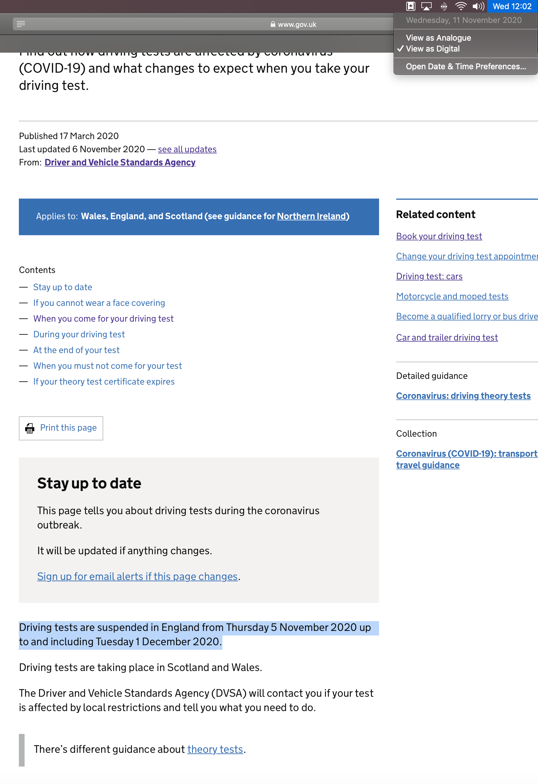

DVSA state: 'You should not carry out driving lessons'  
Where has the word suspended gone?

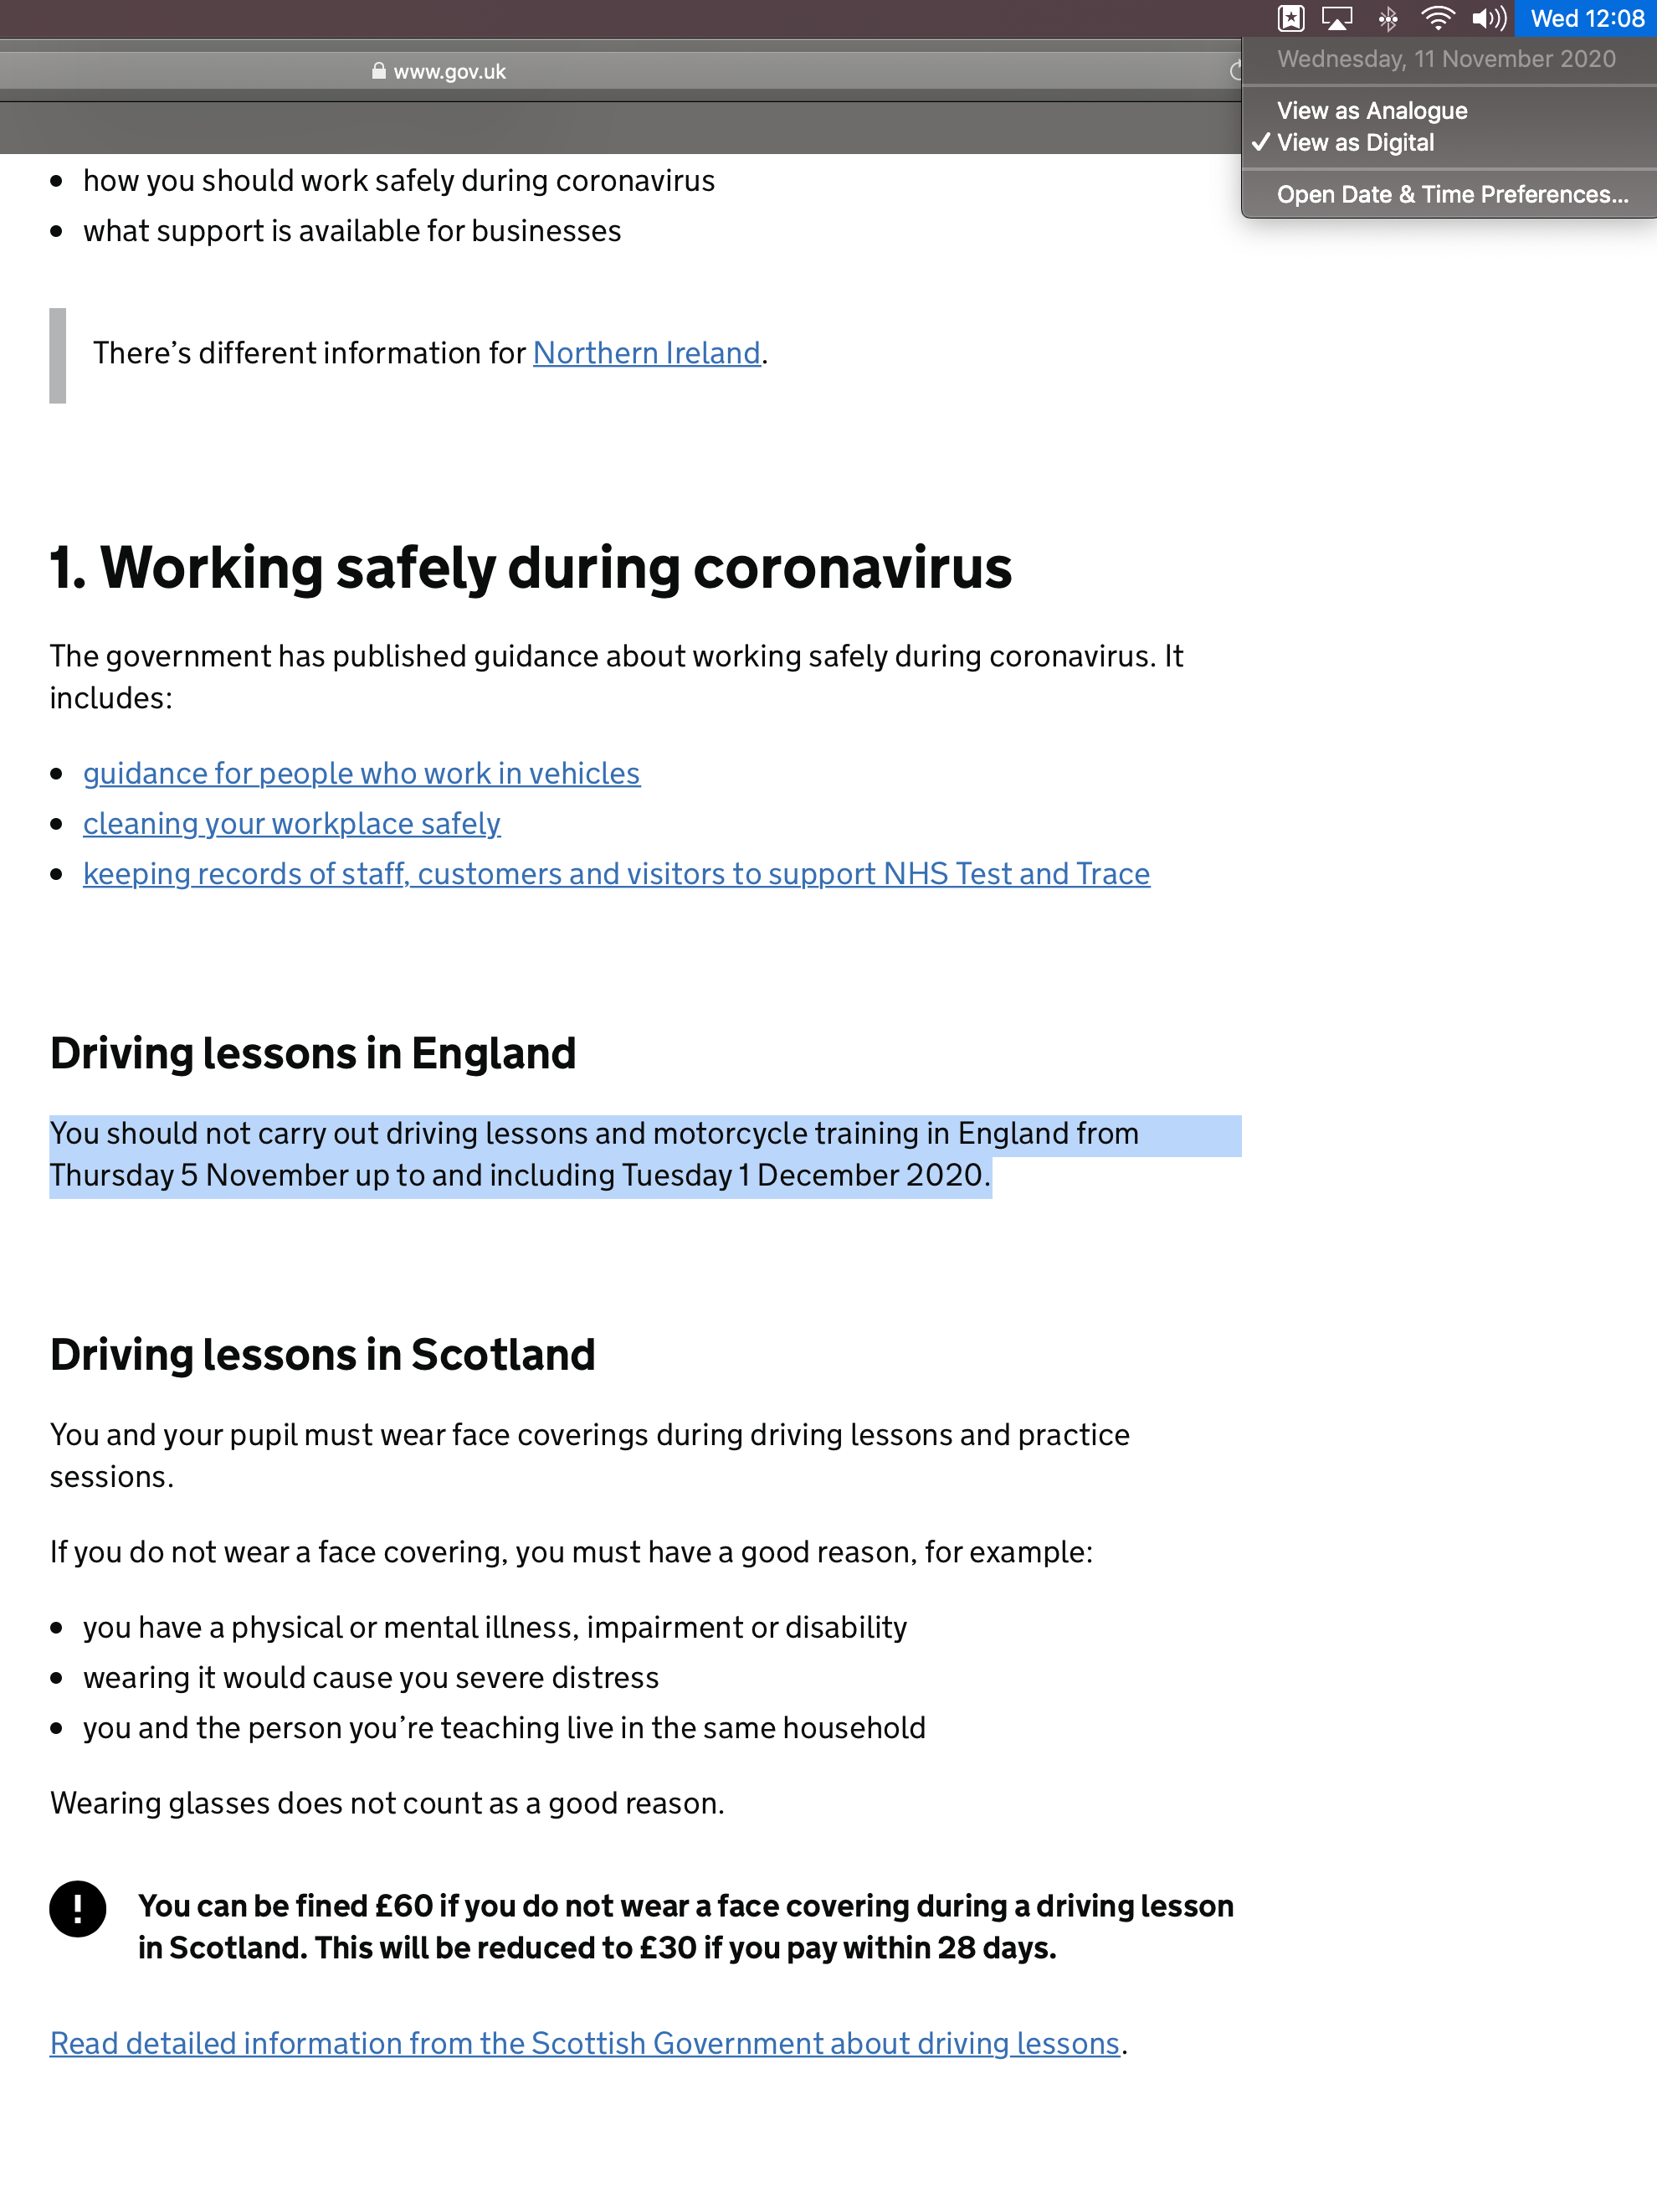

DVSA's initial statement using the word suspended which has now been changed to ‘should’. Why?

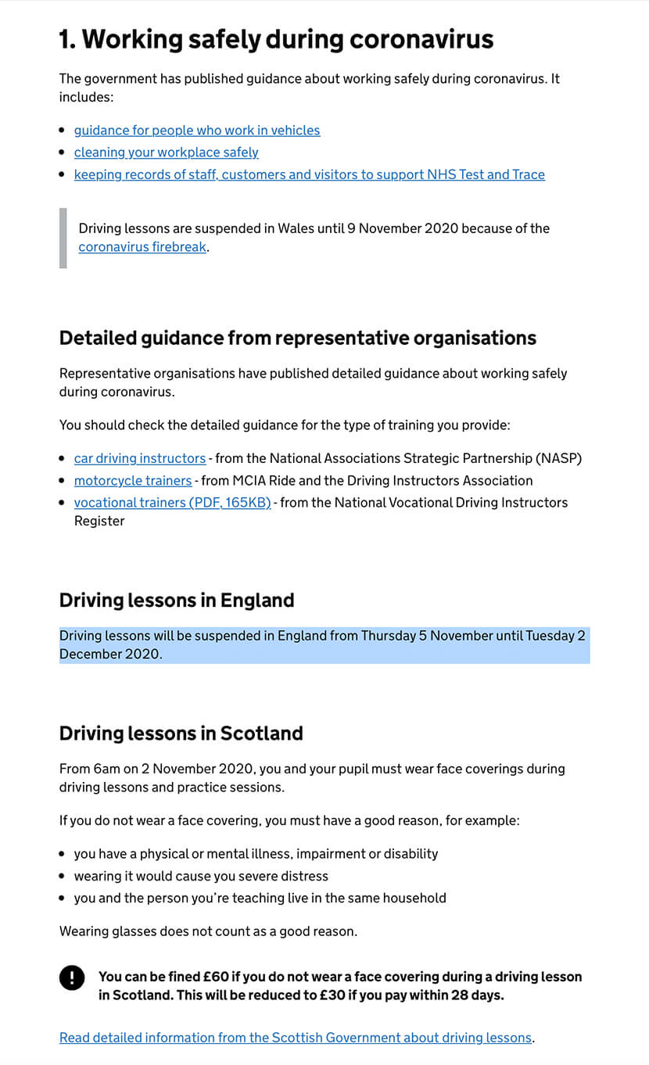

DVSA mention only testing is suspended:

